1. Compile the SPU_BootLoader project as PS3 platform.
2. Compile the SPU program (like xunittest_test) as PS3_SPU platform.
3. Load the *.self file of SPU_BootLoader by ProDG Debugger.
4. Open Module Properties (File-> Module Properties).
5. Set the file server directory (app_home/) which is the directory of SPU program (*.self) in Module Properties

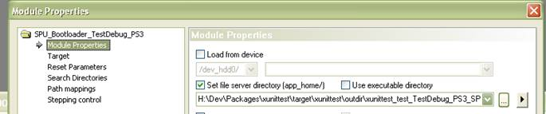

1. Set SPU program’s (*.self) name as Command line parameters in Module Properties

cid:image002.png@01CCE739.10960100.

1. Launch!

**NOTE:**

There is some code in the BootLoader program that handles SPU exceptions, but the code is not working in the Debug mode. Therefore if you’re running unittest with ProDG Debugger, the SPU exceptions won’t be handled and the program will crash at exceptions. You’d better run the SPU unittest with Target Manager, so that the BootLoader can handle exceptions and skip the tests that cause exceptions.

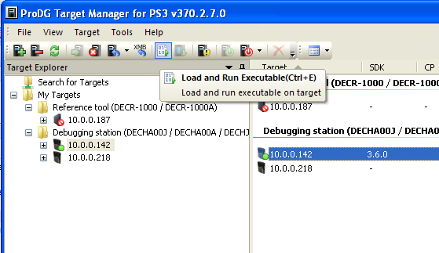

Set the parameters the same way you do in Debugger.

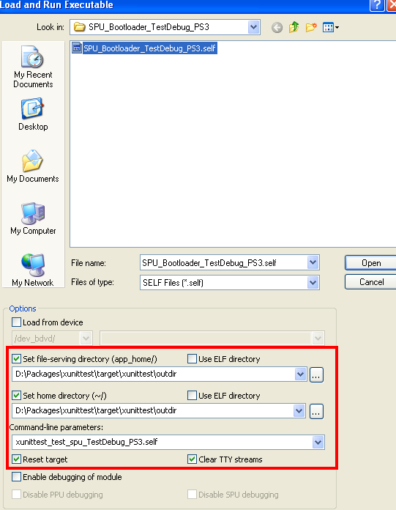

Also, you need to set the Reset Mode to “Debug Mode” in Target Manger. 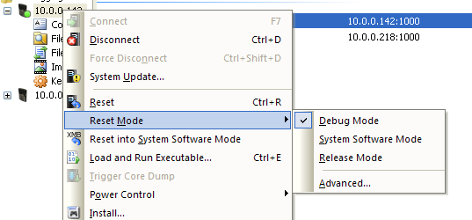

And if you encounter some problem about “PARAM.SFO”, you might need to change the XMB Settings.

